Example

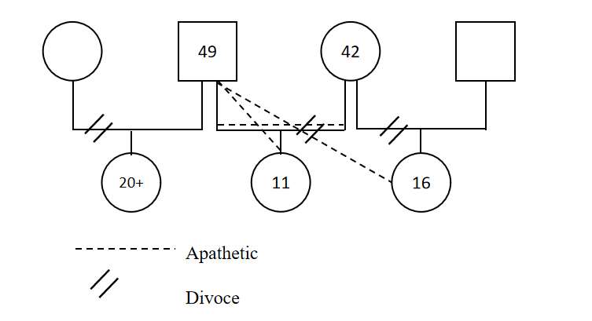

The biggest influence your family has had on you….

Describe a family member who has had an important influence on you????

My mother who has played an essential role in my life. She is my guardian, my friend and my role model.

My mother is in her forties now, but she still maintains a youthful look. In terms of personality, she is an extremely compassionate and kind-hearted person who always takes care of her children. She really is a mother and a friend to me as she always gives me valuable advice and is willing to stand by me through all the ups and downs of my life. Although sometimes she drives me crazy due to her being a perfectionist, I still hold so much pride and respect for her.

I am also influenced by her strong-will. Ever since she was young, she had to learn to be independent as my grandparents were very busy and constantly on the go. She had to take care of almost everything: her younger brother, household chores and herself. Such challenges shaped her into the strong person that she is now…………………

When I remembered that………………